Customer: | Customer Name | Subject: | Subject
Customer Address: | Customer Address | From: | John Doe
Customer Contact: | customer@gmail.com | Company: | Maverick Applied Science, Inc.
Inspection Site: | Inspection Site | Maverick Contact Info: | Cell Phone #: 222-222-2222  Email: contact@gmail.com
Customer PO No.: | 12345 | Maverick Job: | 20251234
Customer CCs: | Customer CCs | Maverick CCs: | Maverick CCs
Inspection Date(s): | 9/29/2025 | Report Date: | 10/03/2025
Introduction: | We met people in the plant.
Entrance Meeting: | They showed us around.
Drawings provided and used during the inspection:
6969DWG
24242DWG
6767DWG
8989DWG
Specifications used during the inspection:
008098SPEC
08080SPEC
0909SPEC
Conclusions and Recommendations: | This is my conclusion and recommendation.

Description | Caption | Picture
big tank with steel supports in the foreground. | up-close image of outside of tank or large pipe. | 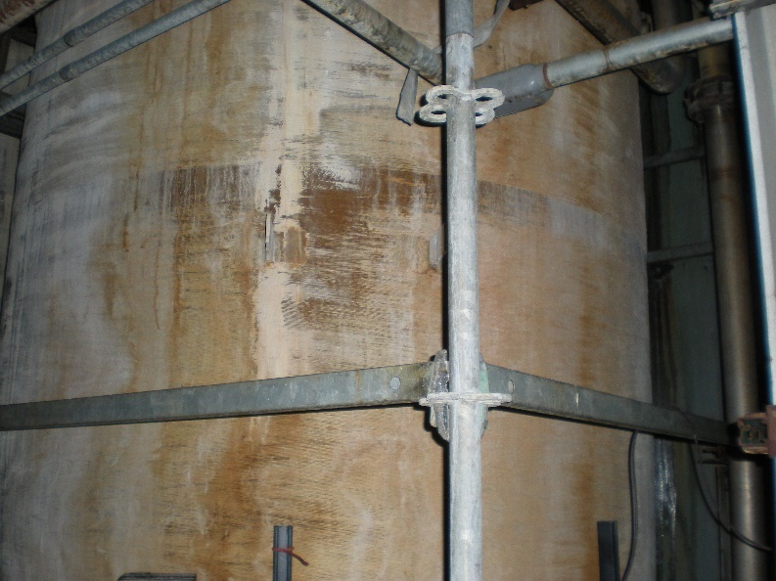
unknown material leaking from pipe nozzle or similar connection. | connection with unknown material. | 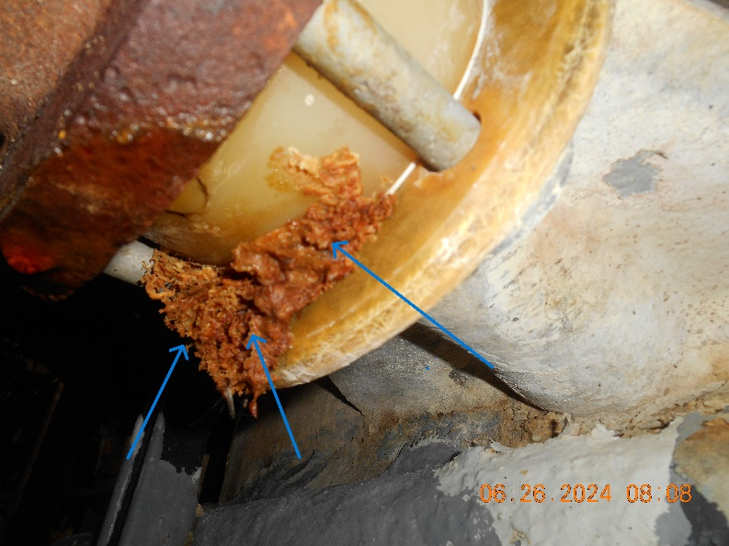
corroded tank grounding lug | tank 8383 grounding lug | 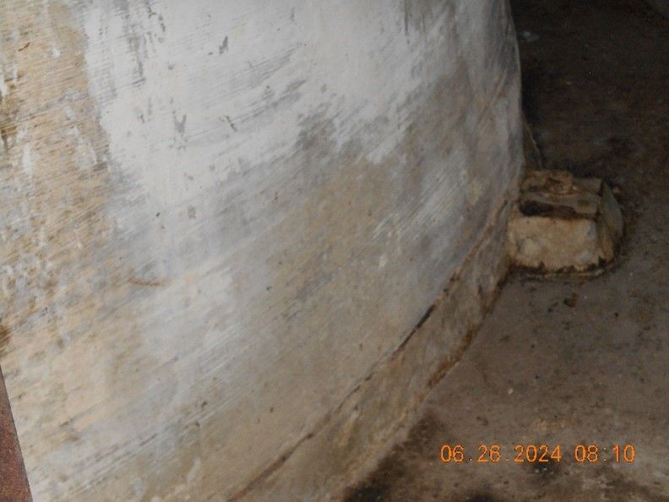
delamination of tank | tank so and so delamination | 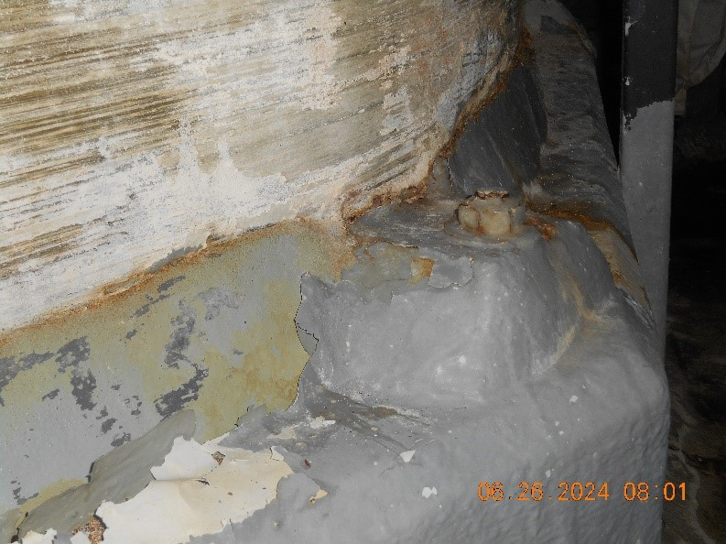
delamination of train B | tank so and so train B delamination

